Psalm 115

May God bless you more and more, bless all your children.
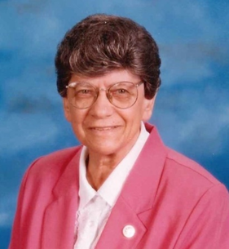
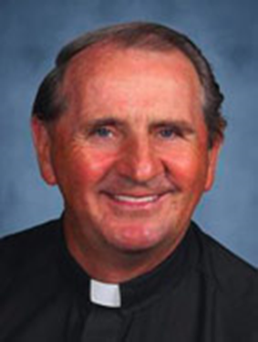
Anyone who remembers our Sister Benedict Kesock, knows that she was in love with and dedicated to St. Charles Borromeo School and Parish. And the feeling was mutual…to the point that she became the only one of our Sisters to ever have a parish hall named after her when St. Charles did so. She was bound and determined to get the school a gym when she was there, and several former pastors will testify to her feistiness in getting it accomplished. She shepherded the school through many accreditations as well. When it was time for her to retire as Principal in 2008, she couldn’t bear to leave St. Charles and stayed on to do pastoral care work in St. Charles’ Circle of Caring Program until her health failed. We are sure she and Father Gerry Creedon are reminiscing about his Gaelic Masses on St. Patrick’s Day and all the good times at the church and school.
Father Gerry
Sister Benedict

From remembrances of the Sisters and www.stcharleschurch.org

Let us pray: Loving God, we give You thanks for the gift of Sister Benedict to us and to St. Charles Borromeo School and Church. Sister Benedict taught us the true meaning of service in which you give your all to those you serve. She brought her Benedictine hospitality to all she met, sometimes in the form of her special spaghetti sauce. Inspire us with her love of life and neighbor so that we may carry on her legacy of care for children, the elderly, the poor and the sick. We ask this through Your Son, Jesus, Who teaches us unconditional love. Amen.

